Answering Quantitative Exams Procedure
May 2021, Last Revised December 2021

Objective- To use a method that will ensure that students are able to complete their assessment(s) in a maximum of two hours and thirty minutes (2 hours 30 minutes) at the most.

WARNING
Students are not allowed to send examination scripts directly to lecturers. Such an action will be considered a breach of examinations rules and procedures and is punishable by the regulations of the University

Those who have been designated to write their examinations at physical centres must inform the Examination Department of their intention to do so before the expiration of the deadline set out by the University. Students who will be writing their examinations at physical centres must bring ONLY their writing materials to the designated centres. Graph papers will be available at all physical centres in case students have need of them.

Scope- Students must use either of the two methods for answering and submitting quantitative exams ONLINE as outlined in the following sections.

Procedure

WARNING
Students are not allowed to send examination scripts directly to lecturers as this action will be considered a breach of examinations rules and procedures and is punishable by the regulations of the University.

Chrome Browser is required
Students who wish to be proctored using ULearn must use the Google Chrome Browser. The ULearn platform will not work with any other browser

Login and Authentication
In order to be ready for the examination on the ULearn platform, it is advisable to log in at least 15 minutes before the exam. This is to enable you log and get properly authenticated by the ULearn system to prevent any delays.

Minimum Machine Specifications
To be proctored on the ULearn platform, it is advisable to use a PC or laptop running a Chrome browser. The system cannot work properly on tablets or mobile phones

Speed of Processor
The speed of your PC or laptop processor should be at least 1.8Ghz and the students will need a RAM specification of about 4GB

Phone or Tablet Not Allowed
Phones and tablets are not to be used.

Submitting Work- Method 1- Using Microsoft Word
Those who choose to submit their work using Microsoft Word should follow the steps below:
- Write all your answers on clean paper. Be sure to number the pages. Write your name and student ID number on each page.
- Take clear pictures of all pages in your answer script in an ascending order (i.e. begin from page 1, etc.).
- Group all images taken in a folder on your computer.
- Copy and paste each image into a Microsoft Word document beginning from page 1. Make sure to give some space between images. An image should occupy a page.
- Name the Microsoft Word Document using your student name and student number.
- Convert the Microsoft Word document you have named to a PDF file
- Upload the document to the Examination Moodle page.
- This completes your submission.

Submitting Work- Method 2- Using CamScanner
The CamScanner (Free) lets you take a photo of your document, identifying the outline of the document and then saving it on your phone.
Other features include annotation, Optical Character Recognition (OCR) to convert words on images to searchable text, cloud storage and sync service.

CamScanner Instruction for Android App:
CamScanner can be downloaded from Google PlayStore if you are using Android or App Store if you are using an iPhone

- On the main menu of CamScanner, tap the Camera icon to enter the capture mode.

- Next, take a photo of each page of the document with your answers.

- The app will automatically identify the outline of the document. To adjust the cropping outline, tap and drag on any of the small circles found around the outline’s perimeter. Once done, tap the Tick icon (at lower right corner).

- Next, you can select the mode that will enhance the clarity of the image. Once done, tap the Tick icon to save it on your phone.

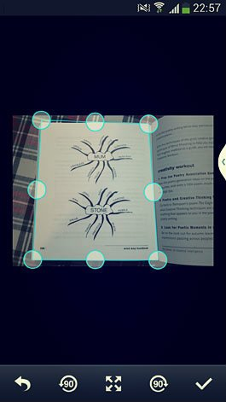 | 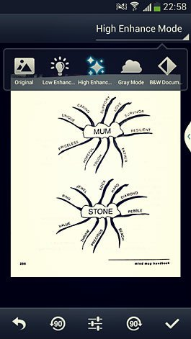
Adjust the cropping outline by tapping and drag on any of the small circles | Select the mode that will enhance the clarity of the image

- On the next screen, you can tap the thumbnail to view the PDF file, edit the title, share and upload to Moodle or other cloud storages, set the tag and etc.
- On the PDF viewing screen, you can rotate the image, make annotation via InNote app and convert the words on the image to searchable text with Optical Character recognition (OCR).
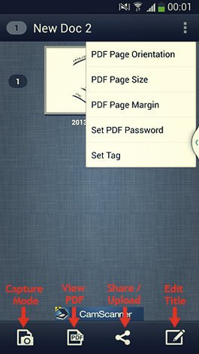 | 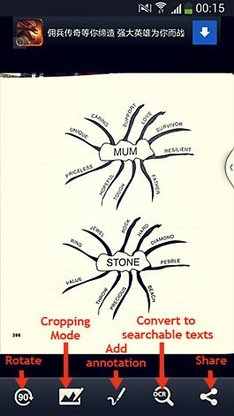
Tap the thumbnail to view the PDF file, edit the title, share and upload | Rotate the image, make annotation

CamScanner Instructions for iPhone Users
- Go to App store on your mobile device and search for CamScanner and install the freeapp.
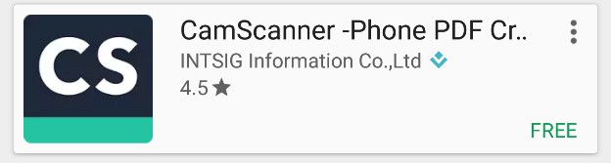
- Once installed open the app. You will need to set up an account if you do not already have one. Press register and follow the instructions to create your account.

- To scan your documents, press on the camera icon in the bottom middle of the screen. This will start your device’s camera, allowing you to take pictures of your documents.

- You will see option for ‘single’ or ‘batch’. ‘Batch’ will group several pictures together into one file for uploading.

- Line up the edges of the pages with the camera frame on your phone. Press the camera icon, to take the picture.

- Once the picture is captured, CamScanner will look for the edges of the page, allowing you to crop out any unwanted background in the photo. Line up the green lines/circles with the edges of your paper. Press the check mark when you have everything in place.

- CamScanner will then automatically enhance the photo. If you are satisfied with the results, hit the check mark to continue. Or adjust as needed.

- The photo will save as a new document. CamScanner will prompt you to rename the document. Press rename if you would like to, otherwise press anywhere else to continue. To add multiple pages to the same document, press the Add (camera icon) button in the bottom left corner of the screen. Repeat steps 4 through 6. Continue this until all pages have been captured and saved.

- After you have scanned/captured the last page of your document, press “More” (three horizontal dots) in the bottom right corner of your screen. You can either save the document to your photo albums as individual photo files or you can upload it to a storage app.

- After the document has either been saved as photos or saved to a storage app, you can now upload that document or photos as an attachment(s) through the ExpertCarePortal.

- To remove old or unwanted documents, go to your “My Doc” folder. In the top right hand of your screen is a check box, select this. Then select the documents you wish to delete and press the trash can. Please note, this will not remove the document from your device if you downloaded the document directly to your device or saved it to a storage app. To remove it from your device or storage app, you will need to go to your download folder or the storage app and delete it from there.

