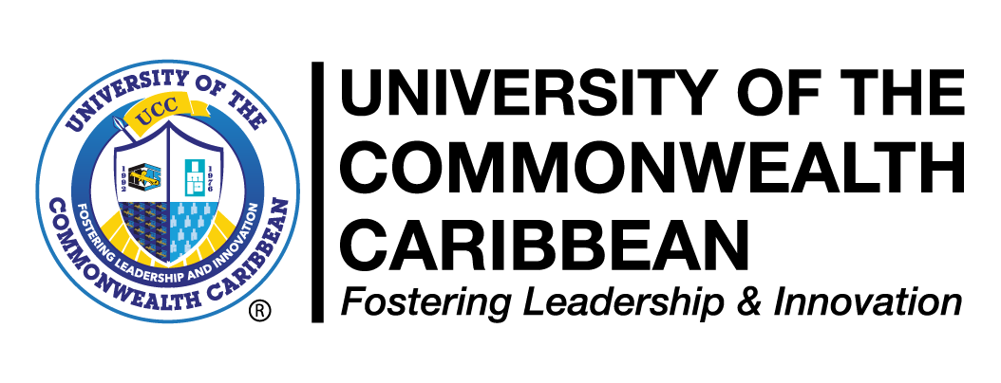
STUDENT ADVISORY
Re: CLASH OF EXAMINATIONS
END OF SEMESTER ASSESSMENTS (EOSA)
SUMMER 2023 [TIMED ASSESSMENTS]
Dear students,
Please scrutinize the Summer 2023 End of Semester Assessments (EOSA) Schedule [TIMED] attached, for individual clash of exams (same date and time for two or more exams). All students who have identified individual clash (es) must complete and submit the Clash of Exams form attached below (THIS REVISED FORM AND NO OTHER) to your programme Coordinator / Campus Manager no later than 10:00am Wednesday August 02,2023.
Students are advised to list all clashes applicable to them.

‘All the best in your exams’

Examinations Manager
July 20, 2023

